

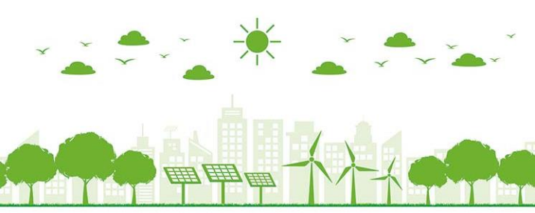The dirty energy crowd can be offset only by the power of the rising clean energy sector and the Indian youths, aroused across party lines

**Dr Dheepanchakkravarthy A Clean and Green Energy 1**

**The work output depends on the energy input and the capability to do work depends on the amount of energy one can control and utilize**

Greek word

***Capacity of Doing Work***

**Dr Dheepanchakkravarthy A Clean and Green Energy 2**



**Energy has been the life-blood for continual progress of**

**human civilization**

| **Year**  **1785** | **Inventor**  **James Watt**  **(Scotland)** | **invention**  **Steam engine** | **industrial revolution Mechanical age** |
| --- | --- | --- | --- |
| **1888** | **Nickola Tesla** | **Commercial induction motor** | **Electrical age** |

**Dr Dheepanchakkravarthy A Clean and Green Energy 3**



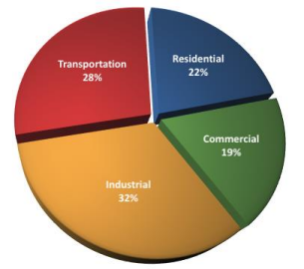

**Dr Dheepanchakkravarthy A Clean and Green Energy 4**

****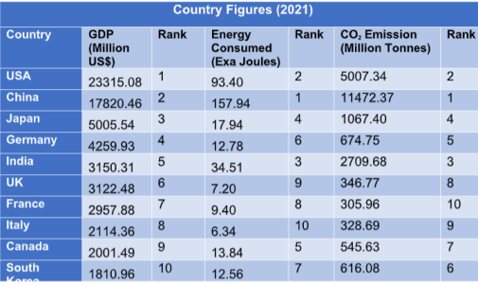

**World's**

**average:**

**About 3**

**MWh/year**

**in 2022**

**Dr Dheepanchakkravarthy A Clean and Green Energy 5**



**Based on**

**Usability**

Primary

resources

Secondary

**Based on**

**Traditional Use**

Conventional

Non

**Based on**

**Long-Term**

**Availability**

Non

renewable

renewable

**Based on**

**Commercial Application**

Commercial Non

**Based on origin**

resources

conventional

commercial Energy

**Dr Dheepanchakkravarthy A Clean and Green Energy 6**



**Dr Dheepanchakkravarthy A Clean and Green Energy 7**



**Dr Dheepanchakkravarthy A Clean and Green Energy 8**



**Dr Dheepanchakkravarthy A Clean and Green Energy 9**

**Commercial Energy Resource Non-commercial Energy**

Available in the market for a definite price Not available in the commercial market for a price

**Examples:** Forms of commercial energy are electricity, coal and refined petroleum products

Energy forms the basis of industrial, agricultural, transport and commercial development in the modern world

**Examples:** Firewood, agro waste in rural areas, solar energy for water heating, animal power for transport, irrigation and crushing of sugarcane

Used especially in rural

households

**Dr Dheepanchakkravarthy A Clean and Green Energy 10**



**Dr Dheepanchakkravarthy A Clean and Green Energy 11**



**Dr Dheepanchakkravarthy A Clean and Green Energy 12**



**World India**

**Dr Dheepanchakkravarthy A Clean and Green Energy 13**





**Dr Dheepanchakkravarthy A Clean and Green Energy 14**



**Dr Dheepanchakkravarthy A Clean and Green Energy 15**

**Dr Dheepanchakkravarthy A Clean and Green Energy 16**

**Dr Dheepanchakkravarthy A Clean and Green Energy 17**



**Dr Dheepanchakkravarthy A Clean and Green Energy 18**



**Dr Dheepanchakkravarthy A Clean and Green Energy 19**



**The continuing rise in the average**

**temperature of the earth’s**

**atmosphere and ocean’s surface**

**due to greenhouse effect**



**Dr Dheepanchakkravarthy A Clean and Green Energy 20**





**Dr Dheepanchakkravarthy A Clean and Green Energy 21**





**Dr Dheepanchakkravarthy A Clean and Green Energy 22**



Energy generated from 

recyclable sources without

emitting greenhouse gases

**Sources**

⮚ Wind

⮚ Solar

⮚ Hydro

⮚ Geothermal

⮚ Bioenergy

⮚ Nuclear

**Importance**

⮚ **Benefit human health (physical and mental) and safety.**

⮚ **No harmful emissions**

⮚ **Environmental health and safety**

Energy which does not pollute the environment and is

renewable in nature

**Sources**

⮚ Sunlight

⮚ Wind Rain

⮚ Tides

⮚ etc.

**Importance**

⮚ **it replaces the negative effects of fossil fuels with more environmentally-friendly alternatives.**

**Dr Dheepanchakkravarthy A Clean and Green Energy 23**



**Dr Dheepanchakkravarthy A Clean and Green Energy 24**



**Dr Dheepanchakkravarthy A Clean and Green Energy 25**





**Dr Dheepanchakkravarthy A Clean and Green Energy 26**

**Energy radiated by the sun**

**Solar Radiation**

**Types:**

Extraterrestrial solar radiation

**Solar irradiation Radiated energy received on earth surface Solar insolation Solar radiation received on a flat horizontal surface on earth**

The intensity of sun’s radiation outside the earth’s atmosphere and it has no diffuse components.

Terrestrial solar radiation Radiation received on the earth surface and is nearly 70% of extraterrestrial radiation **Terms used in solar radiations**

Beam/direct radiation (Ib) Solar radiation received on the surface of earth without change in directions Diffuse radiation (Id)The solar radiation received from the sun after its direction has been changed by reflection and scattering by atmosphere

Total radiation (IT) - Insolation

Sum of beam & diffuse radiations intercepted at the surface of earth per unit area of location. IT = Ib + Id

Airmass (ma)It is the path length of radiation through the atmosphere, considering the vertical path at level as unity.

**Dr Dheepanchakkravarthy A Clean and Green Energy 27**



**Dr Dheepanchakkravarthy A Clean and Green Energy 28**

****Pyranometer

To measure the “total hemispherical solar radiation”

**Dr Dheepanchakkravarthy A Clean and Green Energy 29**

****Pyrheliometer

To measure “beam or direct radiations”

**Dr Dheepanchakkravarthy A Clean and Green Energy 30**



Sunshine Recorder

To measure the “hours of bright sunshine in a day”

**Dr Dheepanchakkravarthy A Clean and Green Energy 31**



(i) Whether they are instantaneous measurements or values 

integrated over some period of time (usually hour or days,)

(ii) The time or time period of the measurements

(iii) Whether the measurements are of beam, diffuse or total

radiation and the instrument used 

(iv) The receiving surface orientation (usually horizontal, it may

be inclined at a fixed slope or normal)

(v) If averaged, the period over which they are averaged.

**Dr Dheepanchakkravarthy A Clean and Green Energy 32**



**Dr Dheepanchakkravarthy A Clean and Green Energy 33**





⮚ India is in the “northern hemisphere“ within latitudes of 7° and 37.5° N.

⮚ The average solar radiation values for India are between 12.5 and 22.7 MJ/m.2 day. ⮚ The peak solar radiation in India occurs in some parts of Rajasthan and Gujrat and is equal to 25 MJ/m2. ⮚ The solar radiation reduces to about 60 percent during monsoon months.

**Dr Dheepanchakkravarthy A Clean and Green Energy 34**



**Dr Dheepanchakkravarthy A Clean and Green Energy 35**



**Example:**

The following observations were made in Bhopal during the mouth of March: Average length of the day = 8.4 hours;

Longest day during the month = 9 hours;

Angstrom’s constants for Bhopal: a = 0.27, b = 0.50;

Solar radiation per day for a clear day = 2100 J/m2. day.

Calculate the average daily global radiation.

**Dr Dheepanchakkravarthy A Clean and Green Energy 36**